Supports for LGBTQ+ people
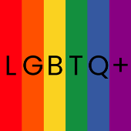 | LGBTQ+ stands for lesbian, gay, bisexual, transgender and questioning.
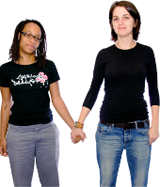 | Lesbian means women who are attracted to other women.
 | Gay means men who are attracted to other men.
 | Bisexual means people who are attracted to both men and women.
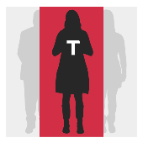 | Transgender refers to people who are now a different gender to the one that they were given when they were born.
 | Questioning is if you feel that you might not be heterosexual but you are not sure.
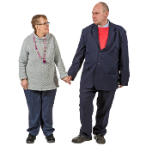 | A heterosexual person is  - A woman who is attracted to men  or  - A man who is attracted to women
For more information about LGBTQ+ people go to https://www.idmhconnect.health/
lgbtq-people/ER

 | Below are services and supports for LGBTQ+ people.
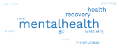 | There is a lot of information.  Some words can be hard to understand.
 | You can ask someone to read this information with you.
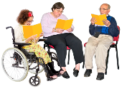 | Family Planning NSW has a Sexuality and Disability Service.  The sessions are included in your NDIS plan.  For more information go to  https://www.fpnsw.org.au/factsheets/  individuals/disability/sexuality-and-disability-service
Family Planning NSW also has Easy Read information about

- Relationships

- Sexual health

- Sexual identity
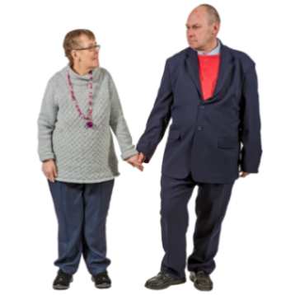 | A relationship is a type of connection you have with a person you enjoy spending time with.
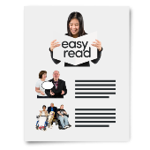 | To read the information go to  https://www.fpnsw.org.au/factsheets/  individuals/disability/all-about-sex
CHANGE has an Easy Read guide on being LGBTQ+.

CHANGE is a group that is not in Australia but the information might still be helpful.
For more information go to
https://www.changepeople.org/our-work/lgbtq-an-easy-read-guide
Twenty10 helps people in NSW between 12 and 25 years old who identify as LGBTQ+.

For more information about Twenty10 go to

https://www.twenty10.org.au/
Twenty10 has services for everyone, not just people with intellectual disability.

Twenty10 provides counselling.

Counselling is when you chat with workers about

- Issues in your life

- Ways you can fix these issues
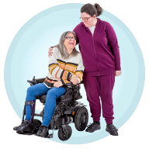 | Twenty10 also provides  - Support for social skills  - Mental health support
Mental health is about

- How you think

- How you feel
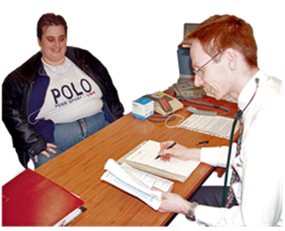 | QLife is a chatline that provides free LGBTQ+ peer support and referrals.  A referral is when someone suggests you see a worker who can support you.
You can

- Call QLife on 1800 184 527 between 3pm and 12am midnight every day

- Chat to QLife online https://qlife.org.au/
Relationships and Private Stuff has counselling and education to support you.

Their services can be included in your NDIS plan.

For more information about Relationships and Private Stuff go to https://www.relationshipsandprivatestuff.com/
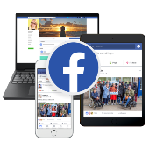 | Sydney Queer and Disability Community is a group on Facebook that raises awareness for LGBTQ+ people with disability.  For more information about the community group go to https://www.facebook.com/  queeranddisabled
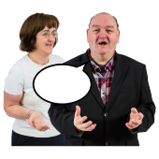 | Rainbow Rights and Advocacy is a self-advocacy group.  A self-advocate is someone who speaks up for themselves.  Rainbow Rights and Advocacy is run by and for LGBTQ+ people with intellectual disability.  For more information go to https://rainbowrights.com.au/
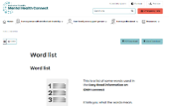 | There are some tricky words in this Easy Read sheet.  For more information about these words go to  https://www.idmhconnect.health/word-list

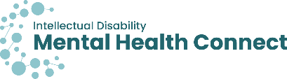
Who wrote this Easy Read

Janelle Weise, Claire Eagleson, Jenna Zhao, Tahli Hind, Dominique Abagi and Julian Trollor.

Where these people work
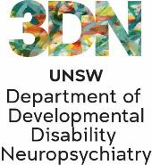 | Department of Developmental Disability Neuropsychiatry UNSW Sydney.  Also known as 3DN.  For more information about who wrote this Easy Read go to https://idmhconnect.health/who-wrote-easy-read
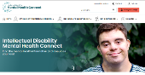  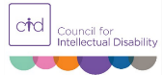 | The Council for Intellectual Disability reviewed this Easy Read sheet.  The information in this Easy Read sheet is from the https://idmhconnect.health/ website
For information on how to support people to use Easy Read go to https://www.3dn.unsw.edu.au/ professionals_toolkit

© Department of Developmental Disability Neuropsychiatry UNSW Sydney 27.01.2023 v2

No changes can be made without asking the people who wrote this sheet.

